Project Design Phase-II
Data Flow Diagram & User Stories

Date | 31 January 2025
Team ID | LTVIP2025TMID56096
Project Name | Flightfider:Navigating your Air Travel Options
Maximum Marks | 4 Marks

Data Flow Diagrams:
A Data Flow Diagram (DFD) is a traditional visual representation of the information flows within a system. A neat and clear DFD can depict the right amount of the system requirement graphically. It shows how data enters and leaves the system, what changes the information, and where data is stored.
Example: DFD Level 0 (Industry Standard)
Example: (Simplified)
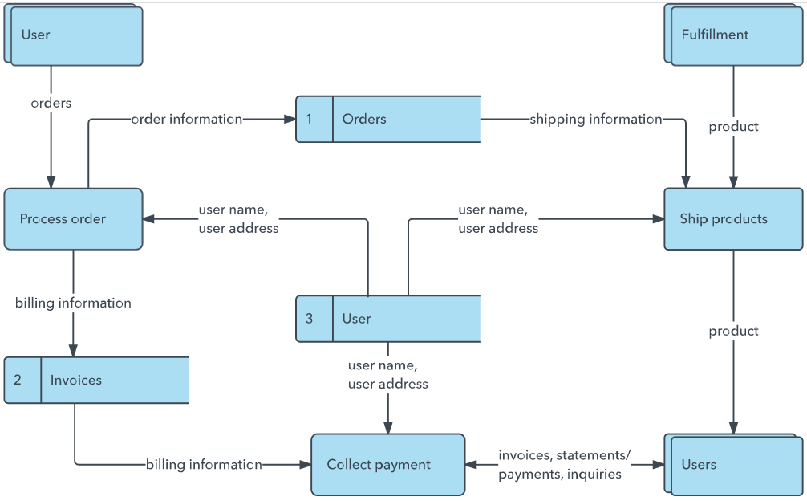


User Stories
Use the below template to list all the user stories for the product.
User Type | Functional Requirement (Epic) | User Story Number | User Story / Task | Acceptance criteria | Priority | Release
Customer (Mobile user) | Registration | USN-1 | As a user, I can register for the application by entering my email, password, and confirming my password. | I can access my account / dashboard | High | Sprint-1
 |  | USN-2 | As a user, I will receive confirmation email once I have registered for the application | I can receive confirmation email & click confirm | High | Sprint-1
 |  | USN-3 | As a user, I can register for the application through Facebook | I can register & access the dashboard with Facebook Login | Low | Sprint-2
 |  | USN-4 | As a user, I can register for the application through Gmail | I can register & access the dashboard with Gmail login | Medium | Sprint-1
 | Login | USN-5 | As a user, I can log into the application by entering email & password | I can successfully log in and access the dashboard | High | Sprint-1
 | Dashboard | USN-6 | As a user, I can view my profile, booking history, and notifications. | Dashboard loads with profile info, booking history, and alerts | High | Sprint-2
Customer (Web user) | Registration &  Login | USN-7 | As a user, I can register and log in via web using email & password. | I can register/login and reach the dashboard | High | Sprint-2
 | Dashboard | USN-8 | As a user, I can view and manage bookings through web dashboard | I can see all my booking data after logging in | High | Sprint-2
Customer Care Executive | Dashboard | USN-9 | As an executive, I can view and respond to user queries. | I can access query dashboard and mark queries. | Medium | Sprint-3
Administrator | Admin panel | USN-9 | As an admin, I can manage users, flights, and view analytics. | I can access admin panel, modify data, and view reports | High | Sprint-3

